**Past R&D**

**Glow Stick**

For the top page

In the 1970s chemists Herb Richter and Ruth Tedrick would invent Chemlite, in which two chemicals were stored separately in the same container; when the chemicals were mixed, light would be emitted for up to 12 hours. This development would lead to a multimillion-dollar commercial industry in light sticks with applications including everything from Halloween safety lights to commercial deep-sea fishing.

For the main page

In 1962, researchers at China Lake Naval Weapons Center in California began to develop a series of “non-fire-producing chemical compounds with the properties of long-lasting luminous intensity and efficiency in extreme temperature conditions.” Glow-stuff.

The outcome of their efforts consisted of two liquids that are stored separately and glow instantly when mixed. The invention was originally used by the Navy for emergency lights, man-overboard float lights, target marking, helicopter landing zone marking, night parachute and paradrop operations, and other similar applications. Later it was put to more aesthetic uses, such as expanding the minds of drug-induced ravers. The inventors are Herbert Richter, Ronald Henry and Joseph Johnson. (U.S. Patent No. 4,626,383, entitled Chemiluminescent System Catalysts, and U.S. Patent No. 4,655,969, entitled Chemiluminescent Systems.)

Glow sticks, also known as light sticks, were standard issue for military personnel in the Gulf War, and current usage within the Department of Defense, according to one website, is about 15 million units per year.

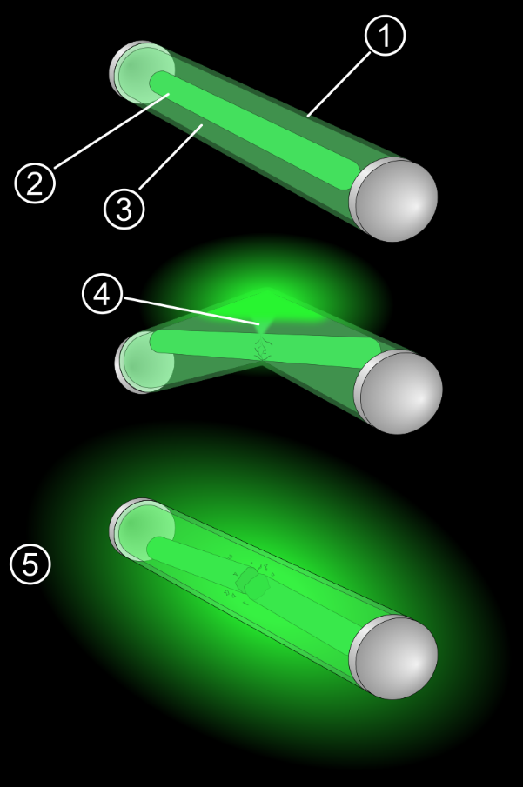

Leave place holder for the Sub Pipe Cleaner and the Port Instrument. We will take care of that. I need to get more information from the historians and get some more photos.

Facility and Mission

The Chemistry Division is located in Michaelson Laboratory at China Lake California. Located in Wing 6 of this historic building, it houses synthetic chemists, polymer chemists, and analytical chemists. The state of the art facility has world class instrumentation (which can be seen in the Research tab). Research focuses on novel energetics, fuels, coatings, polymers, and analytical techniques. There has been many well-documented scientific breakthroughs developed at this facility such as the glow stick and one of the world’s premier explosive CL-20.

(Then the picture you had of the map)

The mission of the Chemistry Division is to support Navy current and future readiness through application of basic and applied research. Future readiness will be supported through basic research into fundamental areas of interest and potential application. In time, this research will provide the basis for advanced technology that will enable the Navy to have game-changing technical advantage over any potential enemy. As part of this future-focused research, the division will maintain a state-of-the-art research facility and will develop scientists with a strong understanding of Navy needs and military specific technology. As such, this facility and these scientists will be able to provide critical support for current weapons and aircraft systems.

(then the place holder image)

And place holder text (we will add after about the org. chart)

(the last photo can be deleted.)

Outreach 1 – Rename to “Science, Technology, Engineering and Math Day – November 8, 2019”

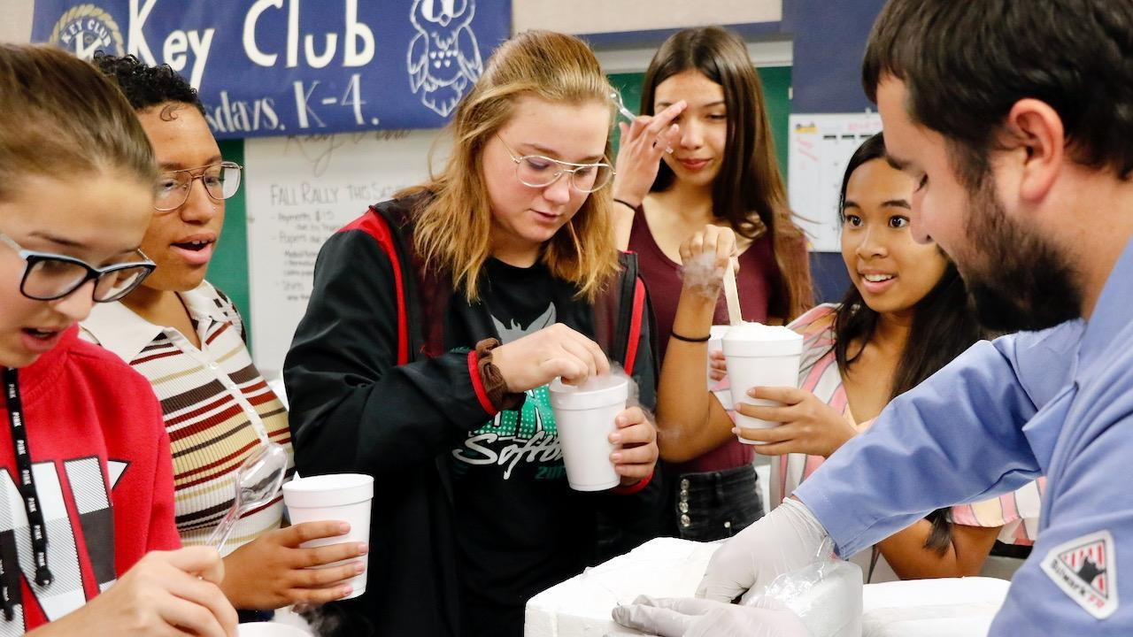

Burroughs High School students in Ridgecrest, California, got a taste of what STEM can mean for them in the future during the Science, Technology, Engineering and Math Day presented by Naval Air Warfare Center Weapons Division professionals at BHS on Nov. 8.

Students rotated between stations featuring 15-minute, interactive presentations highlighting NAWCWD capabilities.

Burroughs High School students mix their own ice cream, made with dry ice, during the BHS STEM day Nov. 8. (U.S. Navy photo by Paul Kakert) Other experiments that chemists performed with students included elephants toothpaste, viscosity measurements, and soda cannons.

Outreach 2 – Rename to “Beer and Learn – October 20, 2021”

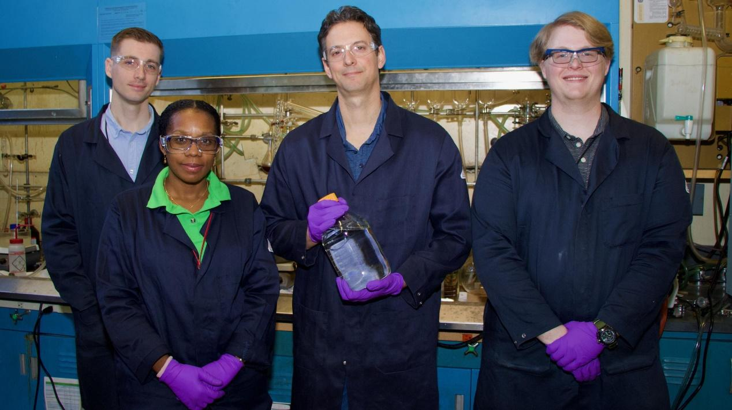Dr. Benjamin Harvey presented at the Local Mojave Dessert Section of the American Chemical Societies’ first “Beer and Learn” event at Flight Line Taproom in Ridgecrest CA. Dr. Harvey presented on the development of biofuels and recent successes from his laboratory group.

The Beer and Learn lecture series aims to disseminate scientific subjects in a broad manner for scientists and non-scientists to appreciate learning about while enjoying a beer.

Outreach 3-5 can just be left as place holders. Thanks!

**Directory**

We can leave this as is. This has been the biggest pain to get public released prior to them seeing the website so the placeholder setup is great

**Opportunities**

NRC link can be updated to [NRC Research Associateship Programs (RAP) (nationalacademies.org)](https://sites.nationalacademies.org/PGA/RAP/index.htm)

Pathways can be updated to [Hiring Programs | NAWCWD (navy.mil)](https://www.navair.navy.mil/nawcwd/now_hiring)

On the opportunities page the four logos.

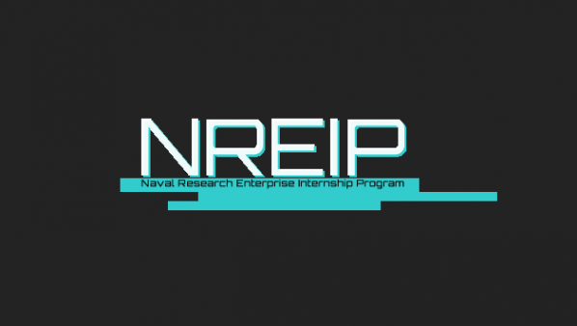 The Naval Research Enterprise Internship Program (NREIP) places college and university students in Department of Navy (DoN) laboratories where they take part in real Naval research for ten weeks during the summer.

NREIP gives academically talented college students, graduating seniors, and graduate students pursuing STEM careers the opportunity to learn about Naval research and technology while receiving first-class mentoring by top scientists and engineers.

NREIP is a competitive program with over 800 placements in 47 laboratories around the country in which many participants go on to careers within the DoN. Interns are selected based upon academic achievement, personal statements, recommendations, and career and research interests. NAWCWD historically hires multiple interns through NREIP annually.

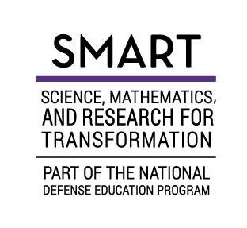

The SMART Program provides STEM students with the tools needed to pursue higher education and begin a career with the DoD. With a full scholarship, students pursuing science, technology, engineering and mathematics (STEM) degrees will be able to focus on complex research to further the DoD’s mission and create lasting impact. SMART is a one-for-one commitment; for every year of degree funding, the scholar commits to working for a year with the DoD as a civilian employee. Summer internships prepare scholars for full-time employment and get them accustomed to working with the DoD.

The SMART program offers qualified candidates: Full tuition, an annual stipend, summer internships, health insurance, miscellaneous allowances, experienced mentorship, employment within the DoD.

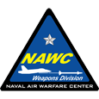 Pathways Intern Program

The Pathways Intern Program is comprised of two types of appointments – Interns and Summer Interns. These programs are available to students in pursuit of: high school diploma, vocational, technical, associate, baccalaureate, graduate, and doctorate programs.

Interns - exposes students to jobs in the Federal civil service by providing meaningful work at the beginning of their career. Interns remain in the program until they meet the program and educational requirements.

Apprentice Internships. Three-year planned career development program at NAWCWD that provides full-time employment, on-the-job training, and merit-based promotions. This program is available to U.S. citizens who are a minimum of 18 years of age and are enrolled half time in a specific educational institution. Click here for more information.

Summer Interns - provides flexibility to both students and the employer by providing temporary employment up to 1 year for students to complete temporary projects, perform labor intensive tasks not requiring subject matter expertise or to work traditional “summer jobs” in areas, which may be unrelated to their academic program.

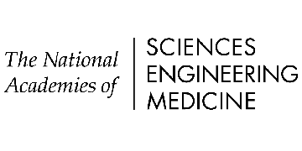

The NRC Research Associateship Programs (RAP) promote excellence in scientific and technological research conducted by the U.S. government through the administration of programs offering graduate, postdoctoral, and senior level research opportunities at sponsoring federal laboratories and affiliated institutions.

In the NRC Research Associateship Programs, prospective applicants select a research project or projects from among a large group of Research Opportunities available through this website. Prior to completing an application, prospective applicants should contact the Research Adviser listed with the selected Research Opportunity(ies) to assure that funding will be available if the application is recommended by NRC Research Associateship Programs panels.

Once a host laboratory and Research Adviser are identified and the applicant has contacted the proposed Research Adviser, an application is submitted through the NRC Research Associateship Programs online application system. Reviews are conducted four times each year, and review results are available to applicants six to eight weeks following the application deadline.

All NAWCWD post-doctoral researchers are hired through NRC RAP.